DevTools Prerequisites for Install
NSCS Devtools Prerequisites

Prerequisites for Install on all systems
We need to have installed the following programs into our computer
- Git
- Node JS version
- NPM
We search for our user folder (In Windows: C:/User/myUserName) and inside we create a file with name ".nprmrc" and inside of it we add the following line:
registry= https://artifacthub-phx.oci.oraclecorp.com/api/npm/npmjs-remote
It is mandatory for employees to be connected to the VPN while using npm. By following previous steps, it will allow us so.

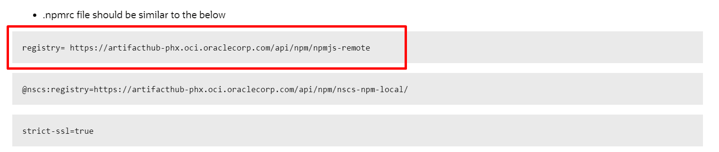
registry=https://artifacthub-phx.oci.oraclecorp.com/api/npm/npmjs-remote
Suelto ahí va el npm file:
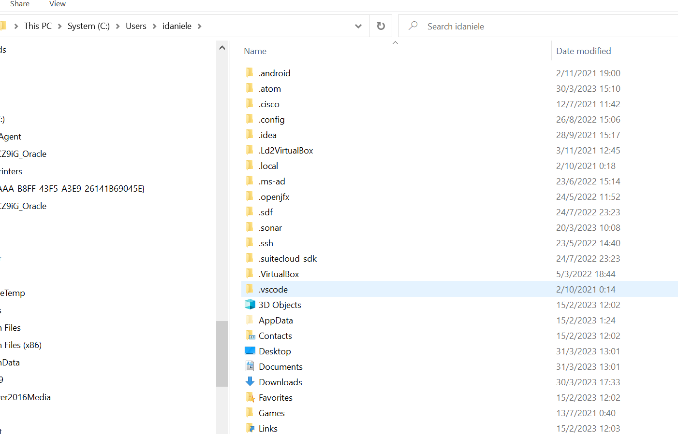
Otra forma:
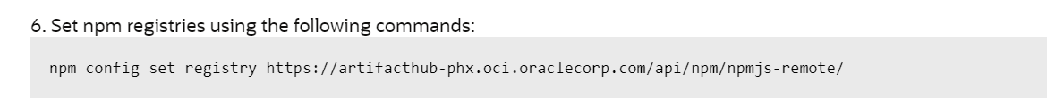

Better just refer to this document:
https://csnetsuite.custhelp.com/app/answers/answer_view/a_id/1003137/loc/en_US
And only say to follow steps 2, 3, 6 and 7 steps

